|  |
| --- |
| **Ansible** |

1. **Create 2 nodes, One is the master one and another is slave one.**

* I have created 2 AWS instances like below:

[i-00dda96833322ea81](https://ap-south-1.console.aws.amazon.com/ec2/v2/home?region=ap-south-1#InstanceDetails:instanceId=i-00dda96833322ea81) – Master

* + 13.235.243.249 – Public IP
  + 172.31.37.15 – Private IP

[i-04e35e8fe5b1c2fa0](https://ap-south-1.console.aws.amazon.com/ec2/v2/home?region=ap-south-1#InstanceDetails:instanceId=i-04e35e8fe5b1c2fa0) - Slave

* + 13.234.122.149 – Public IP
  + 172.31.34.189 – Private IP

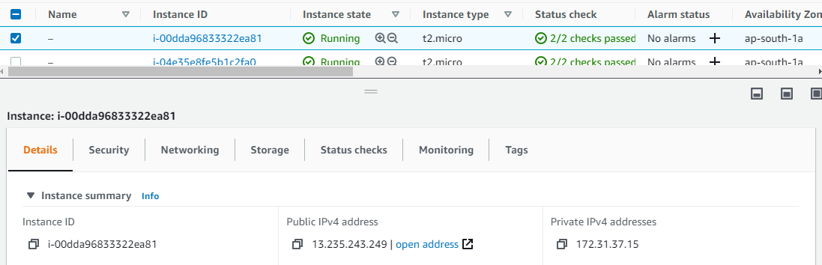

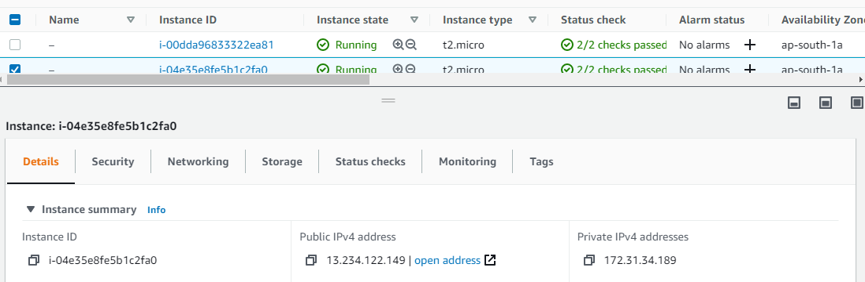

1. **Configure the master node to enable password less authentication.**

* I have performed the below prechecks before installing ansible:
* Checked the ssh service and added the ssh key in the .bashrc. Tested the password less authentication. It works.

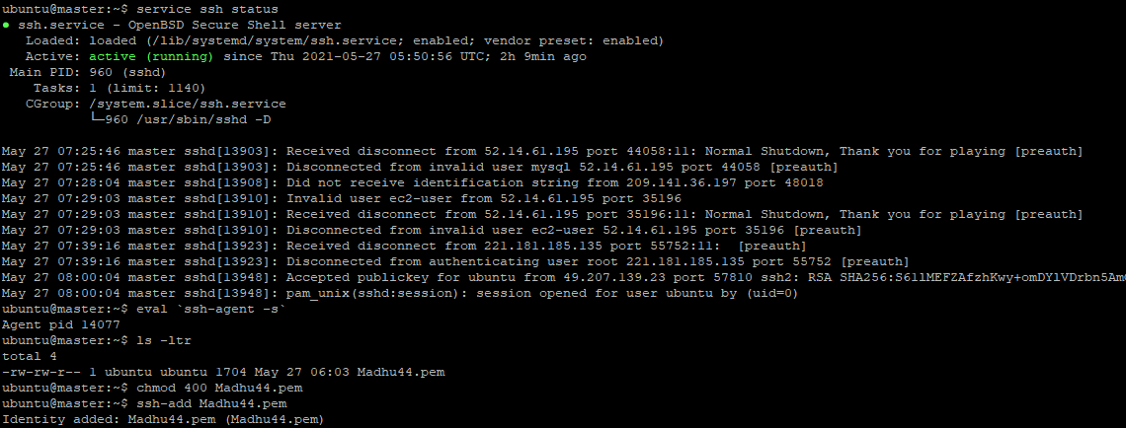

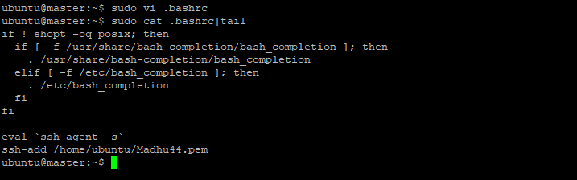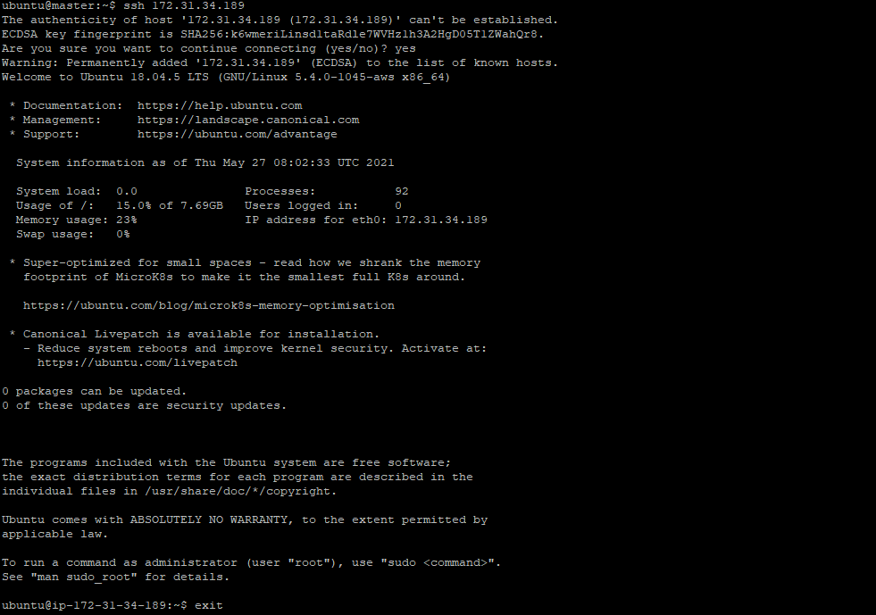

1. **Install Ansible on Master node.**

* Updated the apt cache

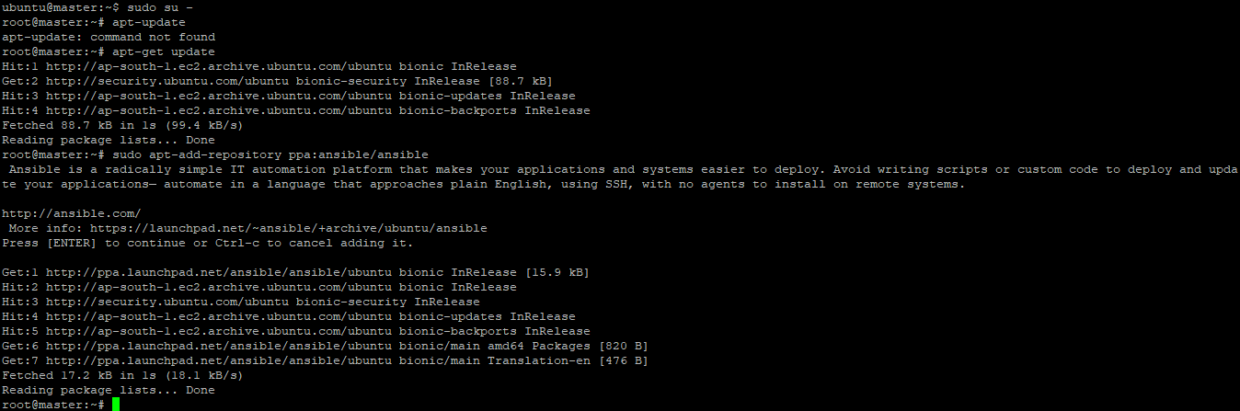

* Installed the ansible with apt-get install ansible

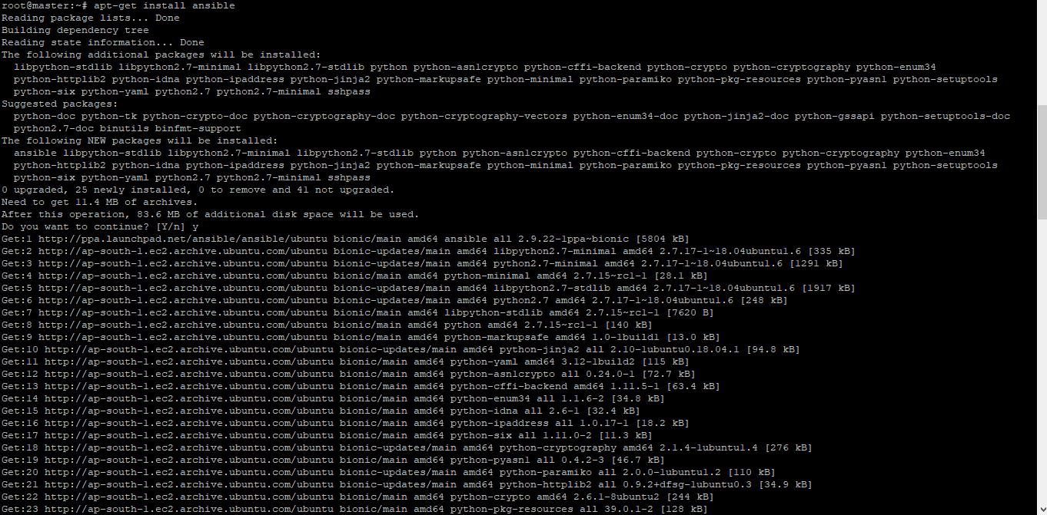

* Checked the ansible version and it is 2.9.22

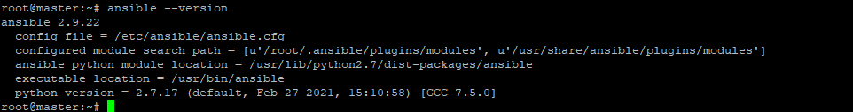

* I have added the slave node’s private ip to the /etc/ansible/hosts in the appservers group. And tested the ansible ping. It works.

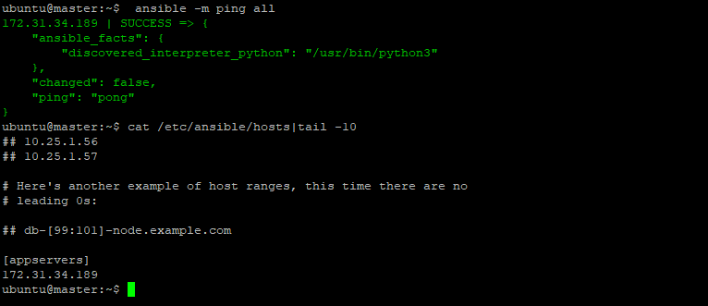

1. **Write a playbook to install following software in the slave node. a. a. Java**

**b. Maven**

**c. Nginx**

**d. Docker**

* Before Writing the playbook, I thought that I should prepare the war file and docker image which should be deployed with ansible.
* I have cloned the git repo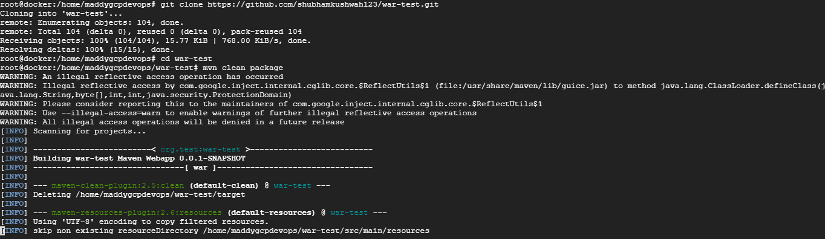
* I have packaged the code with maven

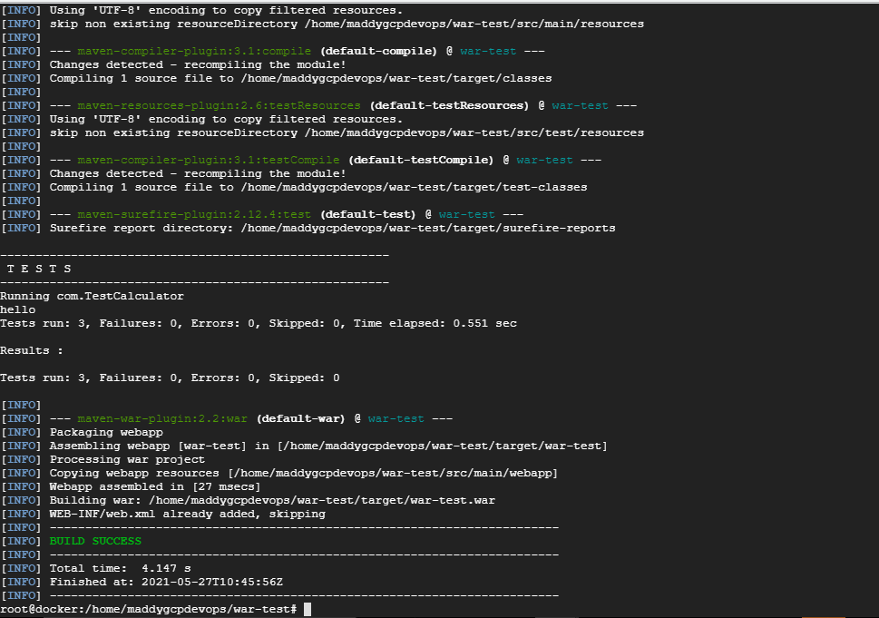

* I have used below docker file to create a tomcat image with the war file deployed. Image name is ailamadu\tomcat:1.0

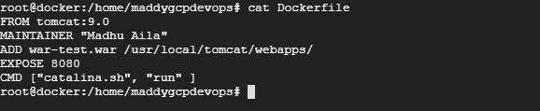

* I have pushed the image to dockerhub

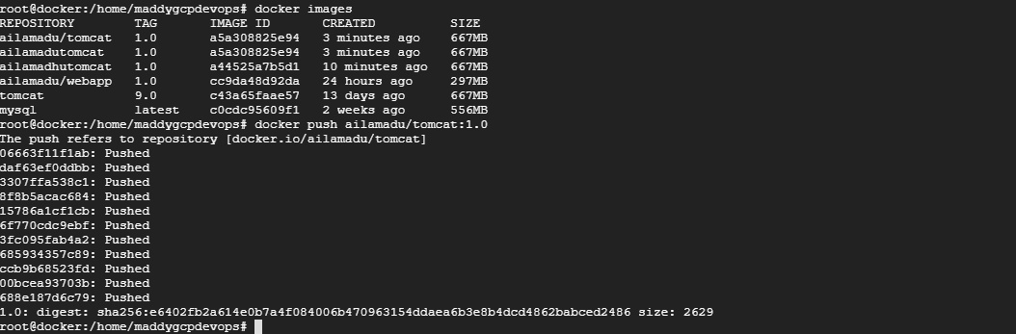

* Now, I came to actual work of writing playbook . Below is the playbook:

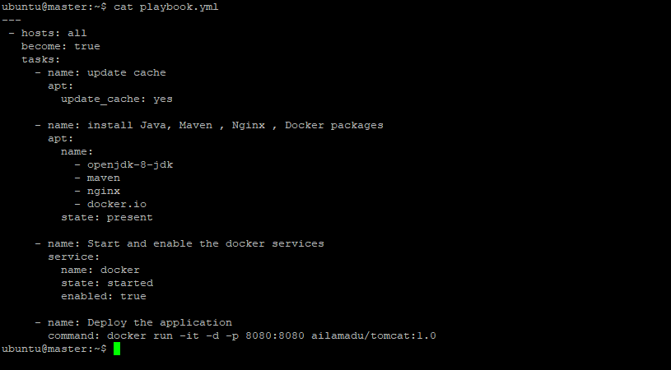

* Since I have some experience in ansible, I have installed the packages in one task instead of mentioning it separately as like demo.
* Apart from that, I have used the command module to run a container with the image that I have uploaded.
* Below is the ansible playbook output. Here I have used all hosts because I have defined only one host in the ansible inventory. I can see that changed status for update cache, package installation and deploy application. It means the provided task is completed with anisble.

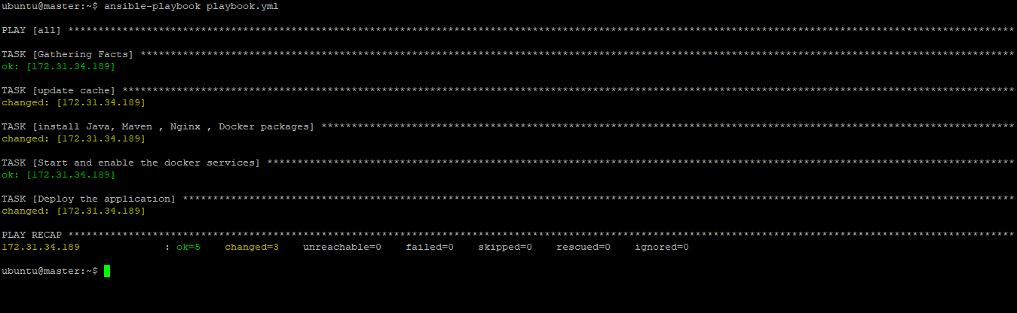

* I have checked in the slave machine and now I can see docker is running and ports are in listening mode.



* Now, I have verified whether the deployed application is reachable or not . I tried with public IP , yes it works.

